Frogspark Content Management System Guide
Navigating to the Admin area

To access the Administration area of your website go to
DEVELOPMENT: http://squaremile.frogspark.agency/wp-admin
Username: nikigiatras
Password: 1LIf#X5D4j6)F*qX9ubBs*dH

LIVE: TBC

Editing Page Content

Each page on your site should have a corresponding Wordpress page.
To view the customisable content of your page visit the pages tab and then select the corresponding page through the administration menu.
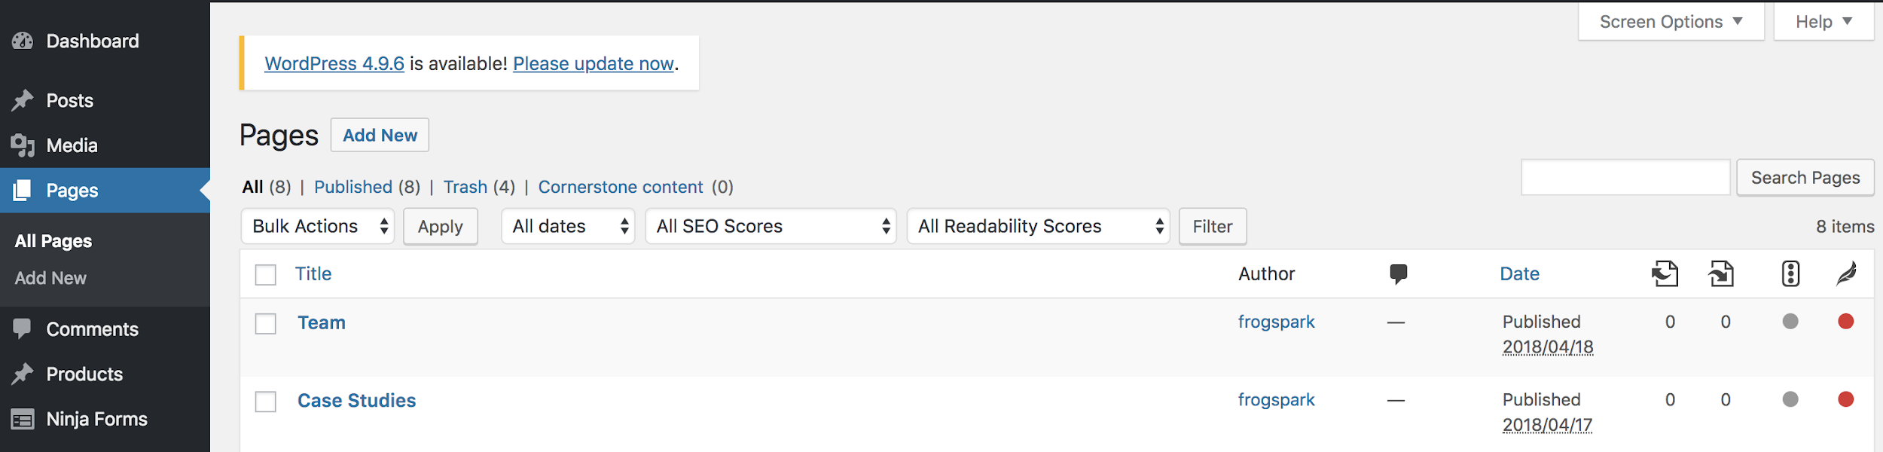
When you view a page in the administration area you will see which areas of the page are editable.

Editing Text

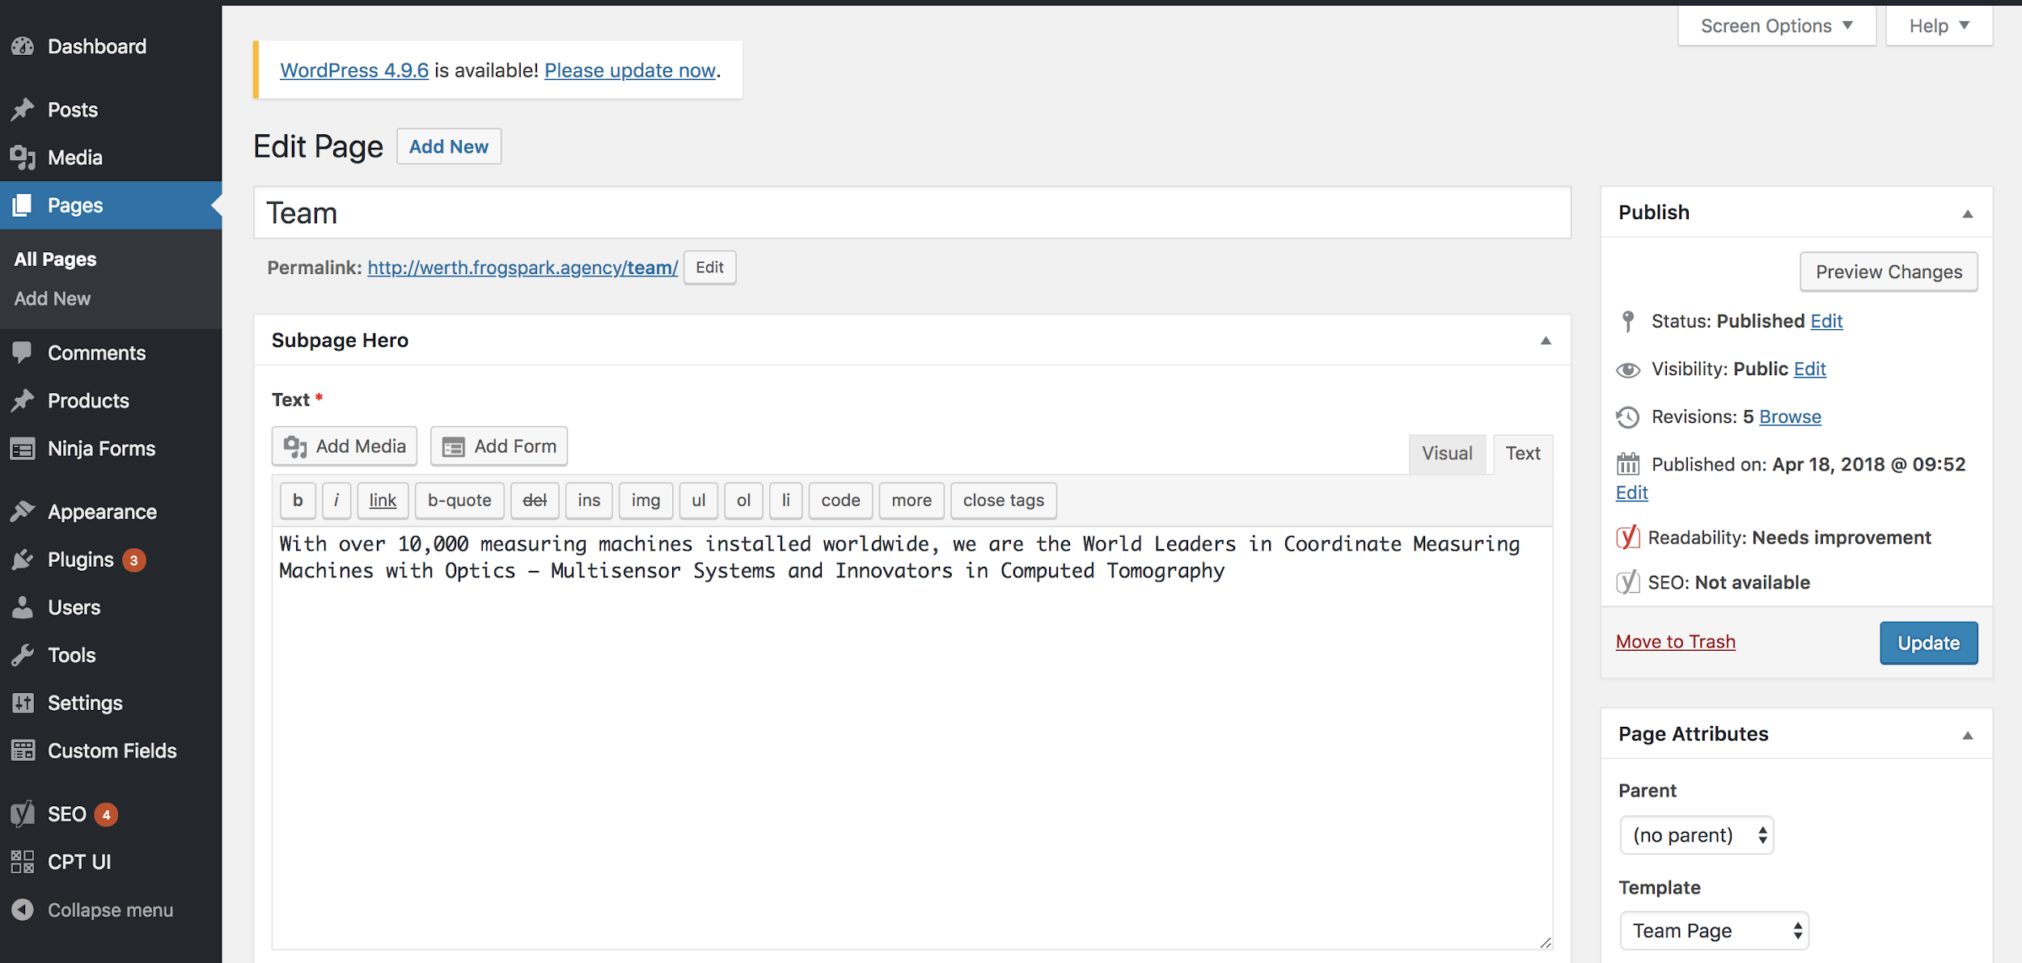
As you can see above, the text in the Hero area is editable on this page. You can change this by typing new text into the textbox.
Editing Images

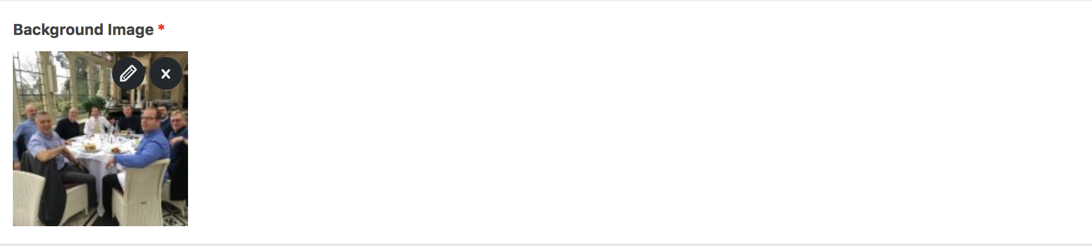

Some images on pages will be editable.

To edit an image press the edit icon (pencil), this will allow you to change aspects of the image.
To remove an image press the cross icon.
When deleting an image you will be prompted to add a new image. To do this click the Add Image button.

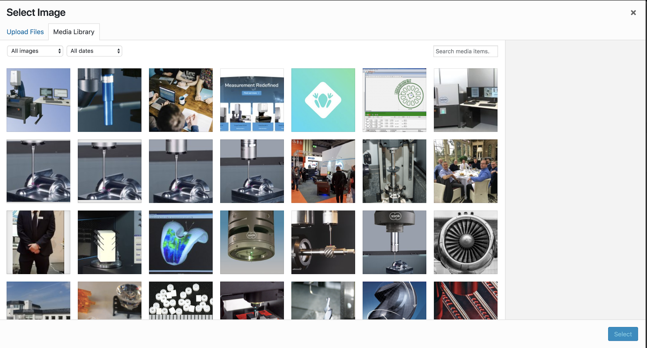
You can choose to add a new image by selecting the Upload Files tab.
Alternatively, you may upload an image that is already uploaded to the site by selecting one of the images from the Media Library tab (seen in the screenshot above).
Side Note: Uploading very large images to the site will affect the site performance, always compress and optimize your images before uploading them.

Updating Repeating Content

Some content on pages will contain multiple instances of content in the same format.
This will appear in a similar format to the screenshot below.

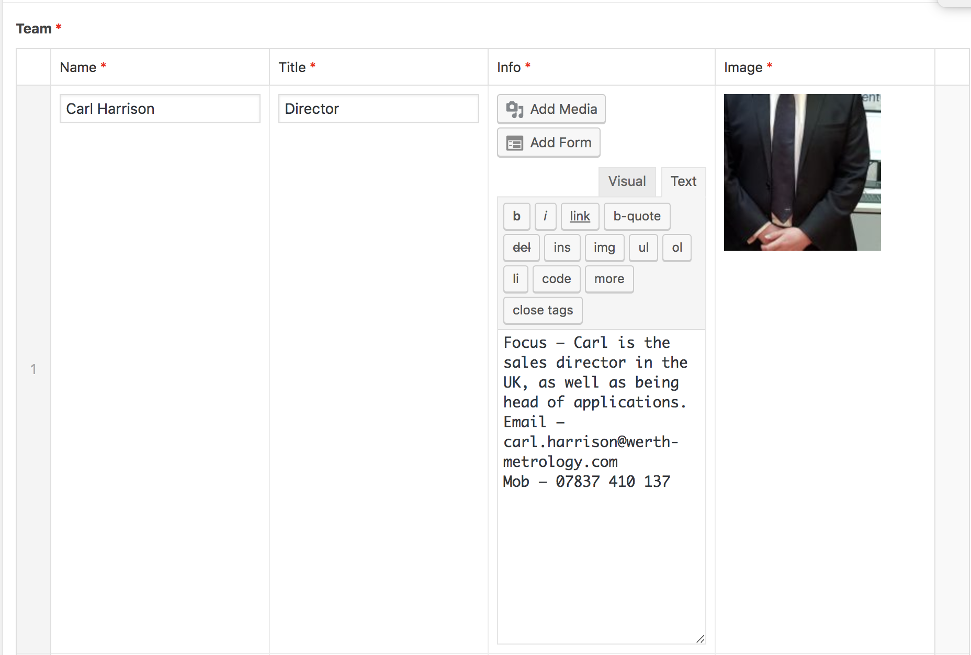

Editing this content works in exactly the same way. To add another member to the team scroll to the bottom of this table and click the Add Row button.

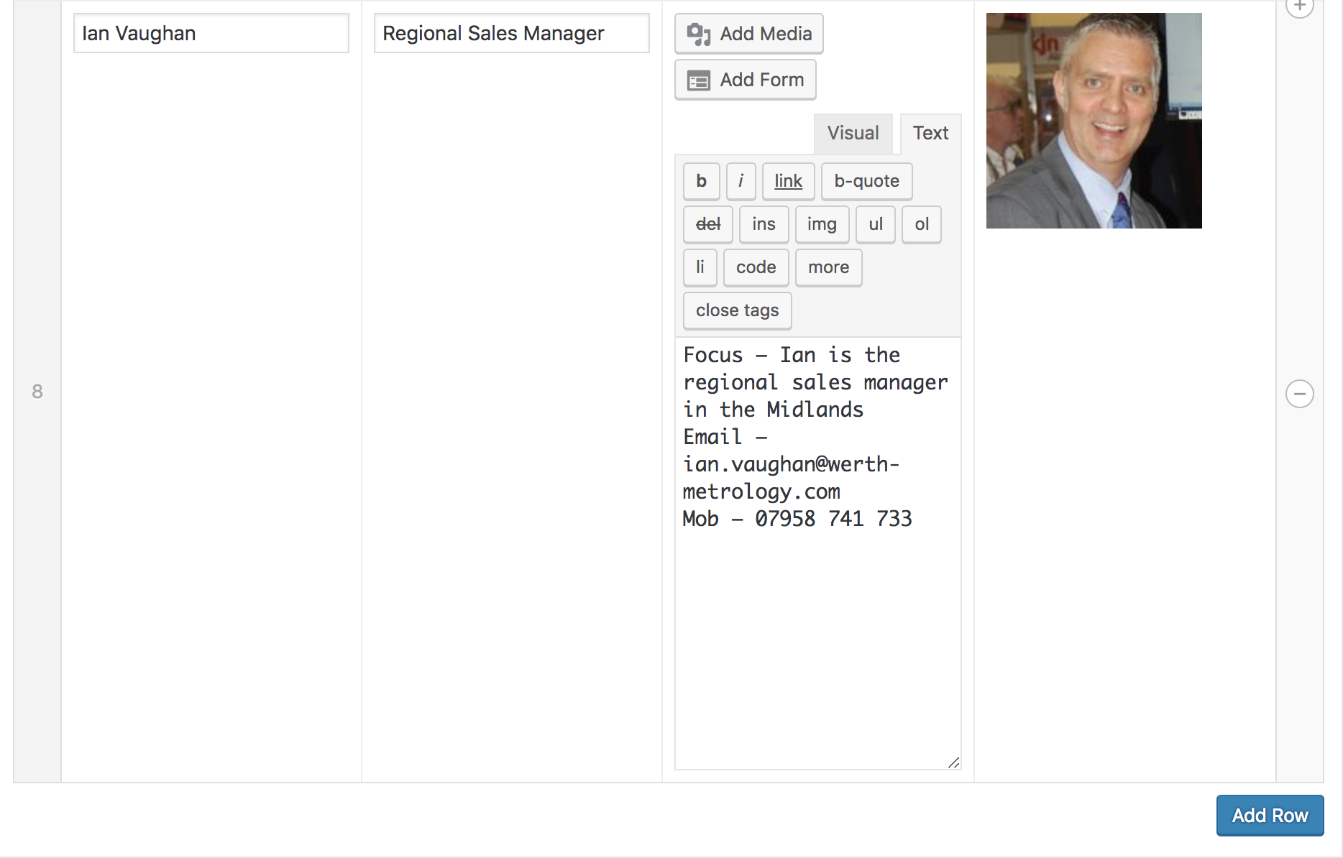

This will bring up a new row of empty content boxes for you to populate with information.
As seen in the screenshot above, there are plus and minus buttons on the right hand side of the table.
Clicking the plus button will add a new row of data above Ian Vaughan, clicking the minus button will remove Ian Vaughan.
Hovering over the grey number column in the content row will change your cursor to the below icon.
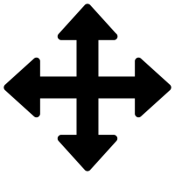
Clicking and dragging will allow you to change which order the rows will be displayed when visiting the page.

Publishing Changes
After making the desired changes to your page you will need to save them.
In order to do this scroll to the top of the edit page view and click the Update button.
You can also preview changes by clicking the Preview Changes button.

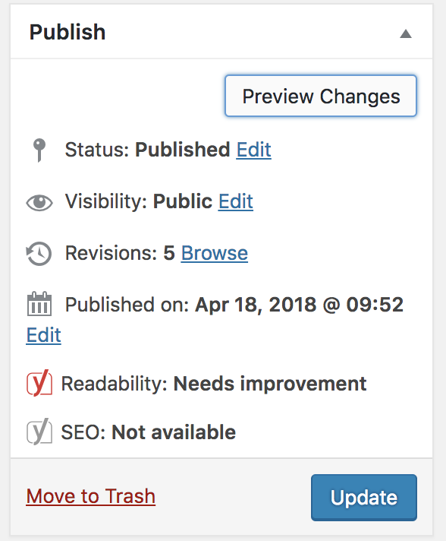

Blog Posts

Adding a blog post

To add a new blog post select the Posts tab in the Administration menu.
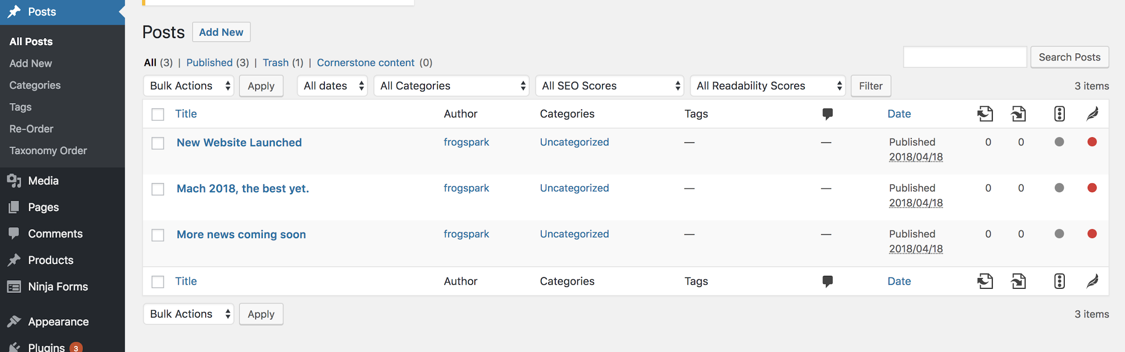

You may add a new post by clicking Add New in the administration menu. Or by clicking the Add New button at the top of the page.

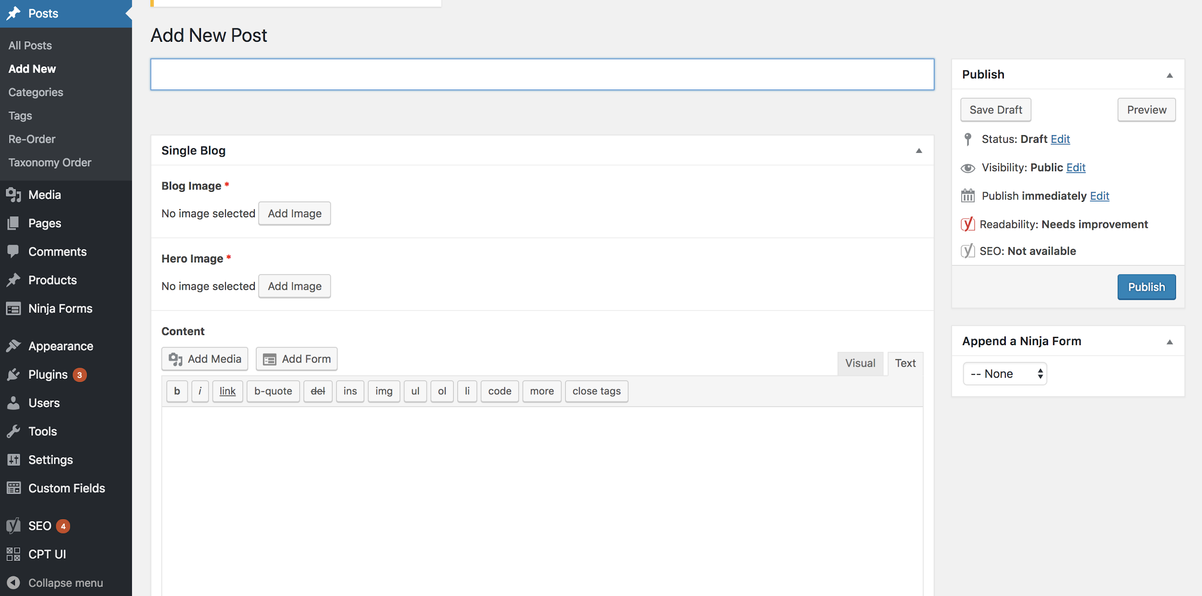
To add a new post complete all of the required fields (*) and then click the Publish button.
Editing Posts

To edit a post select Posts in the Administration menu and then select the corresponding post.
Published Posts
When you save a post it is published to your website. You can visit it from the administration area by clicking the Permalink below the post title. This is generated automatically based on the initial post title. You may edit this if you wish by clicking the Edit button.

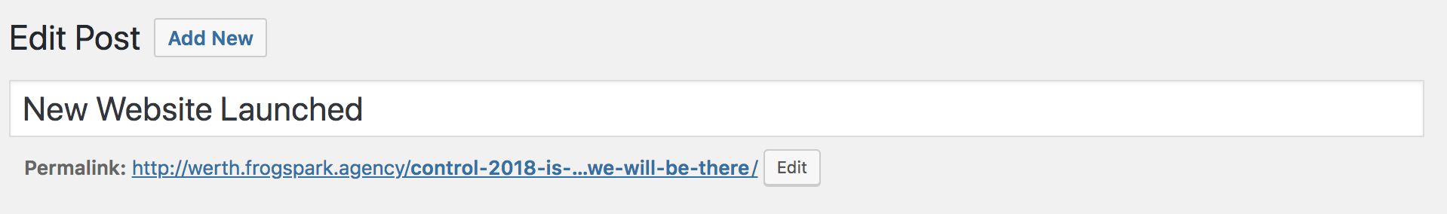

If you wish to backdate a blog post you may do this from the Publish area at the top right of the Edit Post page. From here you can also Unpublish a post if you would like to temporarily remove it from the site.
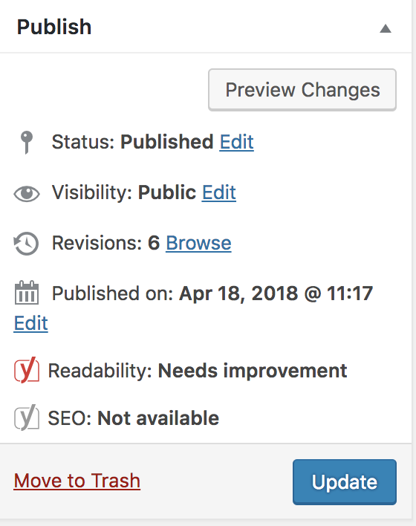
Deleting Posts

To permanently remove a post and its content from the site navigate to Posts in the administration menu.

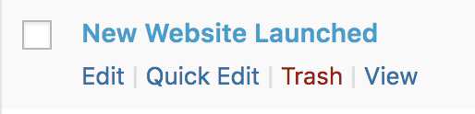

If you hover over a post you can quickly delete it by selecting Trash.

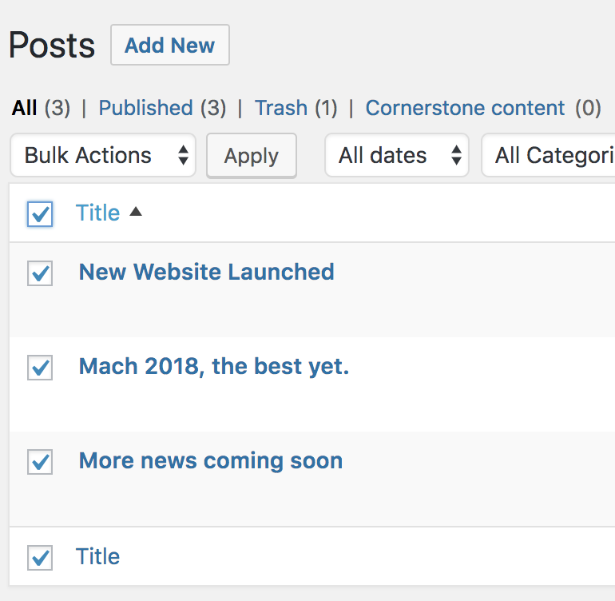
To bulk delete use the checkboxes on the left hand side of the table. Then click the Bulk Actions dropdown menu and select Move to Trash. To apply this click the Apply button.
To finalise the deletion process visit the trash by selecting Trash in the menu above the posts table.

Repeat the same process as above but select the Delete Permanently option to permanently remove posts from your site.

Custom Post Types

Some of our bespoke sites contain multiple content types. In the example site below we have a custom post type of Products.

Editing and deleting custom post types works in exactly the same way as editing a blog post or page.

Adding Users

If you need to give multiple people access to your site then you will need to add more user accounts.

To do this visit the Users tab in the Administration menu.

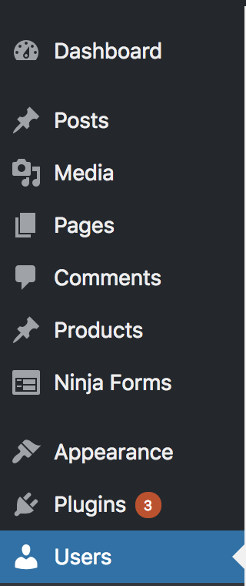

Here you will see a list of all User accounts registered on the site in the following format.
To add a new user click the Add New button at the top of the Users page.
Complete the form as shown below and click Add New User to create a new account.

When adding a new user a strong password will be automatically generated for you. It is essential that you either use the strong password or create a strong password of your own. Not doing so could pose a huge security risk for your website.

Make sure to select the appropriate Role from the dropdown menu.
Administrators are allowed the highest privileges on the site, so be careful who you grant this access to. It is strongly advised you read about User Roles before creating accounts (see below).
Read more about Wordpress User roles here: https://codex.wordpress.org/Roles_and_Capabilities
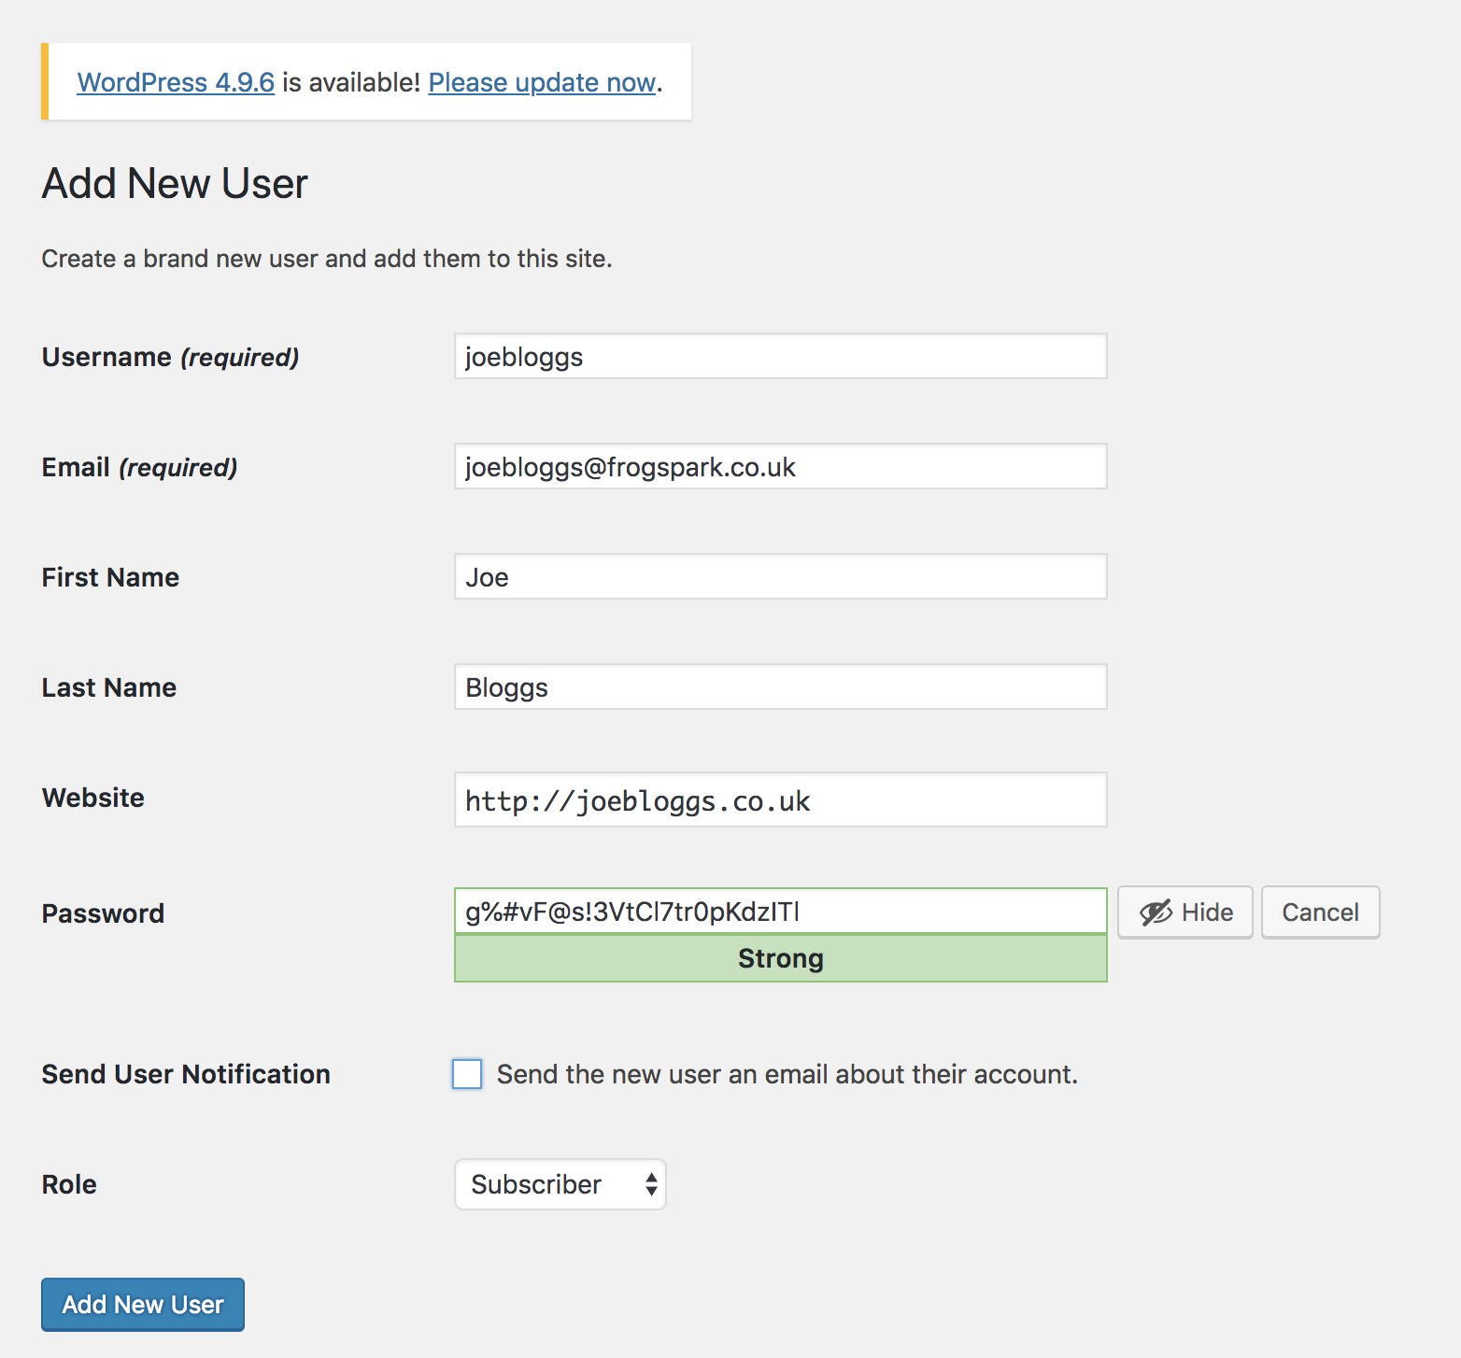

Editing and Deleting Users

Editing and deleting users has the same process as editing or deleting posts but this time from the Users page.
Depending on the format of your website you may have user profile pictures or information that will be editable from your user edit page. You can customise this from the edit page on the corresponding user

Other Useful Tips

You can bulk upload images / files to the media library to expedite the adding / editing content process.
To do this select the Media tab in the Administration menu, then click the Add New button.
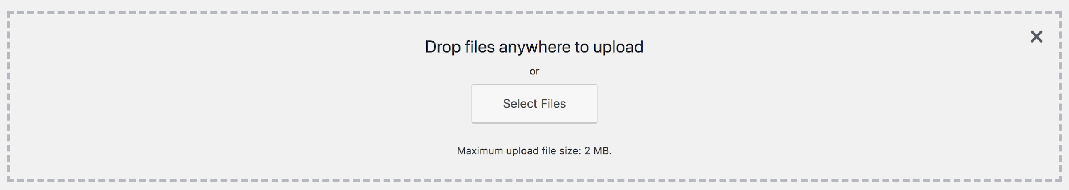
After doing this you can drag and drop images into the above box or choose to select files to upload from your file browser. When selecting files you can shift / ctrl click to select multiple for upload.
Once the files are uploaded they will be accessible from the Media Library when adding or editing content.

Other Media Library Tips

If you delete a post that includes an image that has been uploaded to the site, the image will still remain as an upload in the Media Library, you can delete it from here by clicking on the image in the Media Library grid and selecting Delete Permanently.

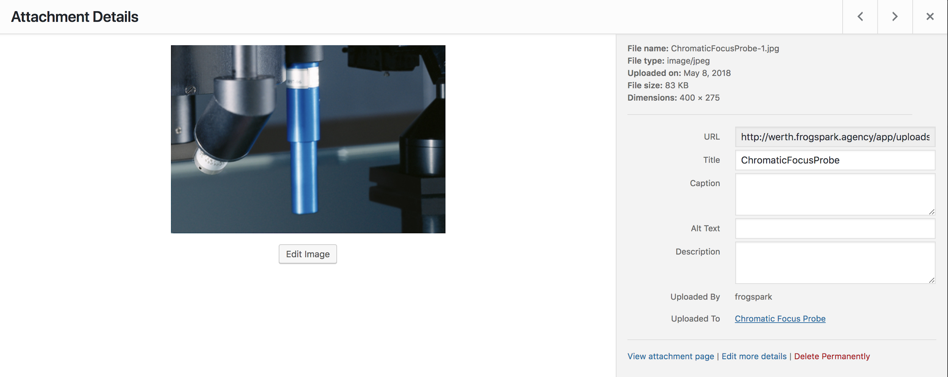

You can also edit images by either clicking the Edit Image button or by clicking the Edit more details link on the right.

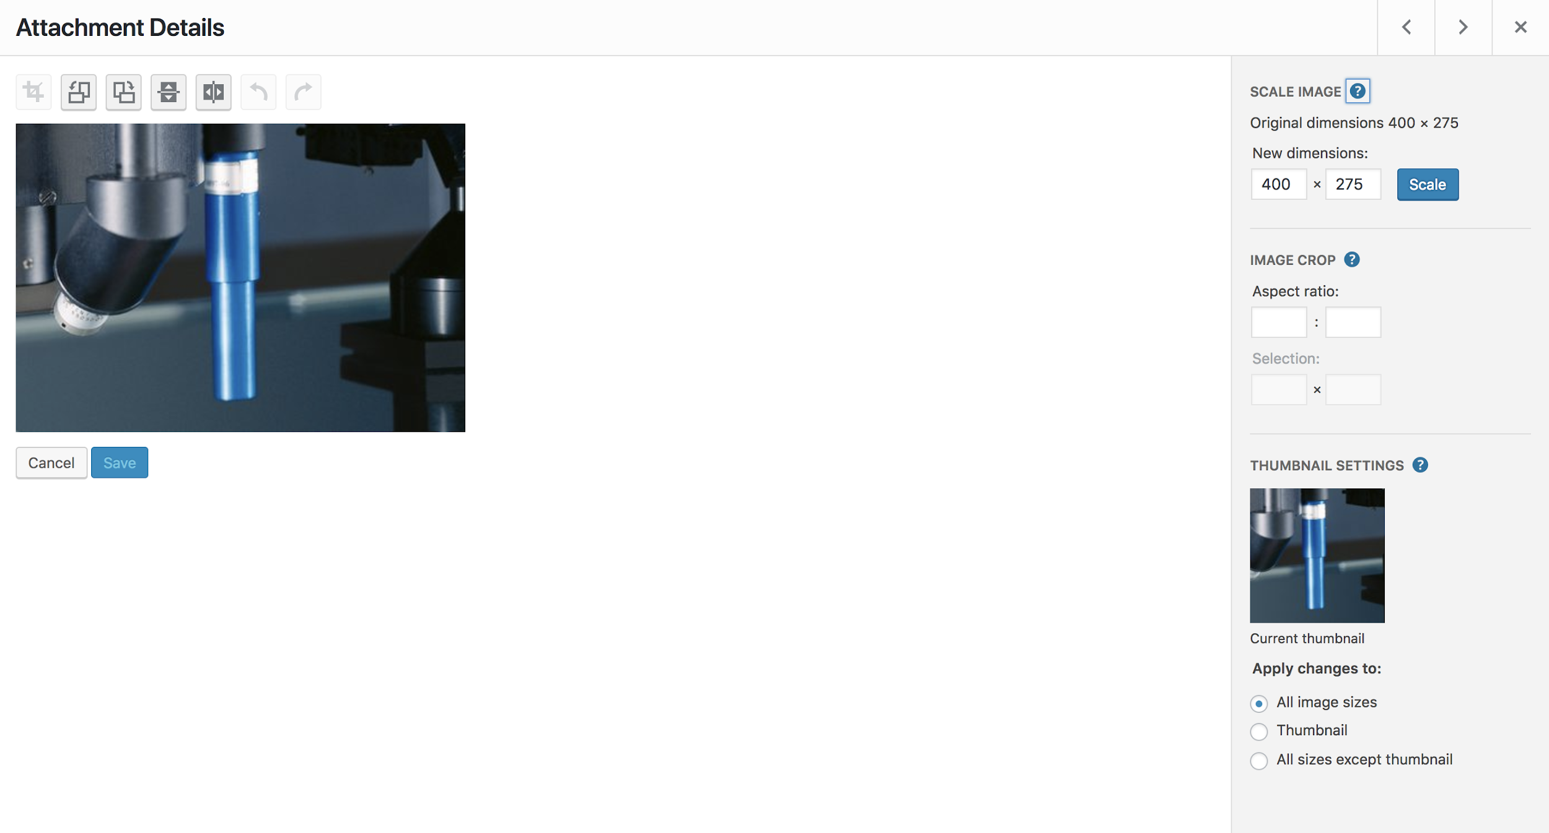
Editing an image allows you to resize and crop images. This is useful if you have no access to photo editing software.

